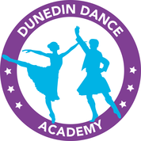Dunedin Dance Academy Branded Clothing Order Form

CHILDS NAME: CHILDS CLASS:

ITEM NAME & CODE | SIZE | AMOUNT
Postage |  | £3.00

TOTAL :

All orders must be handed in on an order form, with full payment in either cash or cheque (cheques made payable to Dunedin Dance Academy) and in a sealed envelope. Orders can be handed to your class teacher. As these are made to order returns are not possible unless faulty so please ensure you order the correct size! Postage is £3.00 per order.

